**Exercise 1: Control Structures**

**Query:**

CREATE TABLE CUSTOMERS (

    CustomerID   NUMBER PRIMARY KEY,

    Name         VARCHAR2(100),

    Age          NUMBER,

    Balance      NUMBER,

    IsVIP        VARCHAR2(5) DEFAULT 'FALSE'

);

CREATE TABLE LOANS (

    LoanID       NUMBER PRIMARY KEY,

    CustomerID   NUMBER REFERENCES CUSTOMERS(CustomerID),

    InterestRate NUMBER,

    DueDate      DATE

);

INSERT INTO CUSTOMERS VALUES (1, 'Alice', 65, 12000, 'FALSE');

INSERT INTO CUSTOMERS VALUES (2, 'Bob', 45, 8000, 'FALSE');

INSERT INTO CUSTOMERS VALUES (3, 'Charlie', 70, 5000, 'FALSE');

INSERT INTO CUSTOMERS VALUES (4, 'David', 30, 20000, 'FALSE');

INSERT INTO LOANS VALUES (101, 1, 7.5, SYSDATE + 15);

INSERT INTO LOANS VALUES (102, 2, 8.0, SYSDATE + 40);

INSERT INTO LOANS VALUES (103, 3, 9.0, SYSDATE + 10);

INSERT INTO LOANS VALUES (104, 4, 6.5, SYSDATE + 5);

COMMIT;

**Output**:

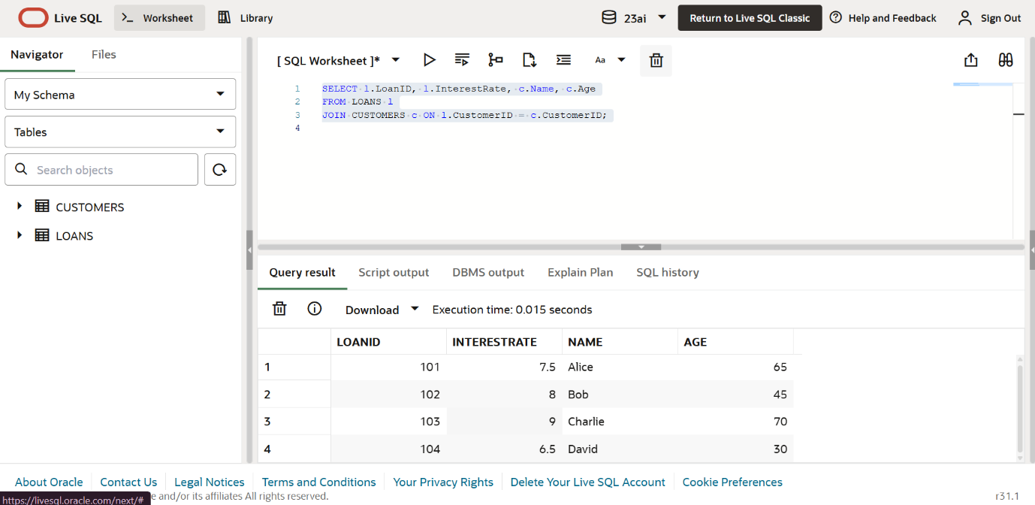

**Scenario 1 Query:**

BEGIN

    FOR cust IN (

        SELECT CustomerID FROM CUSTOMERS WHERE Age > 60

    ) LOOP

        UPDATE LOANS

        SET InterestRate = InterestRate - 1

        WHERE CustomerID = cust.CustomerID;

    END LOOP;

    COMMIT;

END;

/

**Scenario 1 output:**

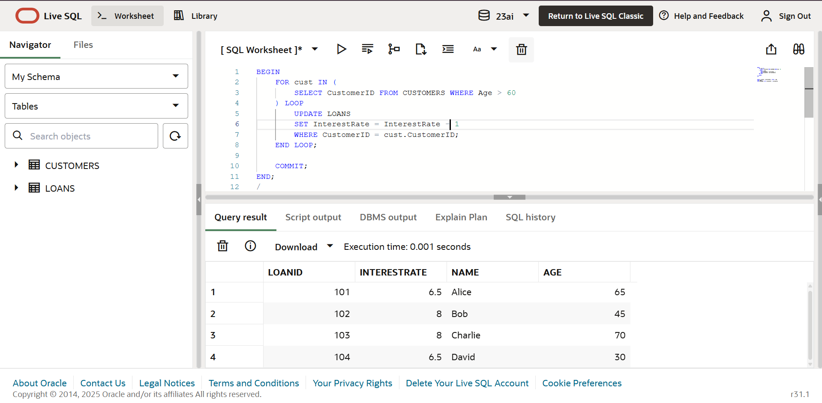

**Scenario2 Query:**

BEGIN

FOR cust IN (

SELECT CustomerID FROM CUSTOMERS WHERE Balance > 10000

) LOOP

UPDATE CUSTOMERS

SET IsVIP = 'TRUE'

WHERE CustomerID = cust.CustomerID;

END LOOP;

COMMIT;

END;

/

**Scenario2 Output:**

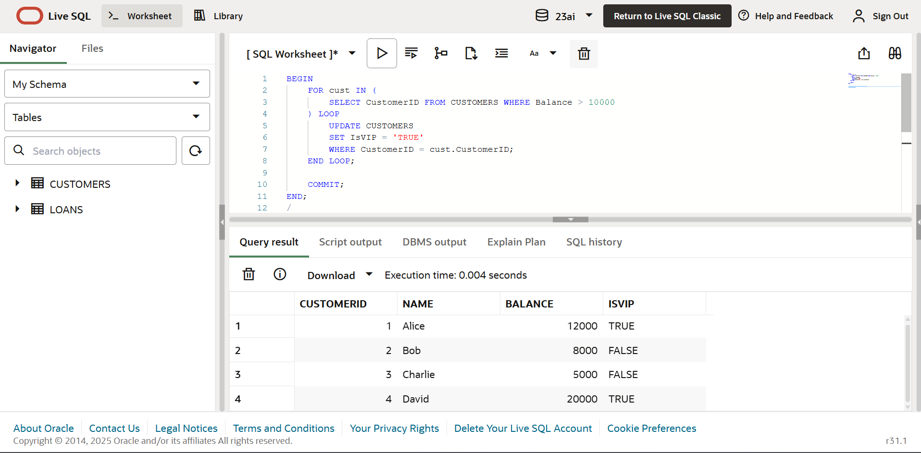

**Scenario3 Query:**

SET SERVEROUTPUT ON;

BEGIN

    FOR rec IN (

        SELECT c.Name, l.LoanID, l.DueDate

        FROM LOANS l

        JOIN CUSTOMERS c ON l.CustomerID = c.CustomerID

        WHERE l.DueDate <= SYSDATE + 30

    ) LOOP

        DBMS_OUTPUT.PUT_LINE('Reminder: ' || rec.Name ||

                             ', your loan (ID: ' || rec.LoanID ||

                             ') is due on ' || TO_CHAR(rec.DueDate, 'DD-Mon-YYYY'));

    END LOOP;

END;

/

**Scenario3 Output:**

